CSC175 Data Communications & Networking

Spring 2026 Midterm Exam
Student Name: ID： _s
Total Points
Note: This exam paper should be kept confidential and any dissemination violates copyright.
Q0 | Q1 | Q2 | Q3 | Q4 | Q5 | Q6 | Q7 | Q8 | Q9
/10 | /10 | /10 | /10 | /15 | /10 | /10 | /10 | /5 | /10

Q0 (10 points) Multiple-choice questions: enter your answer keys here:
1 | 2 | 3 | 4 | 5 | 6 | 7 | 8 | 9 | 10

For the following multiple-choice questions, each question has exactly one correct answer key. If multiple choices are correct, choose the option “All of the above”. Fill in the answer keys in the table above. (Answer keys written in the question area will not be counted.)
1. The Internet is "Best-Effort" at Layer 3. What does this mean?
A) The network guarantees 100% delivery of all packets
B) The network will tell you immediately if a packet fails to arrive
C) The network tries its best to deliver packets but makes no guarantees
D) The network prioritizes important emails over video streaming
2. What is the main function of Layer 4 (Transport Layer)?
A) To convert digital signals into analog waves
B) To build reliable delivery (e.g., re-sending lost packets) on top of Layer 3
C) To physically connect two machines with a wire
D) To route packets between different towns
3 Which switching approach is more efficient for bursty traffic (e.g., web browsing)?
A) Circuit switching, because it reserves capacity
B) Packet switching, because it doesn't waste reserved capacity on idle periods
C) Both are equally efficient
D) Neither is efficient for bursty traffic
4.Why is Packet Switching better than Circuit Switching at handling network failures?
A) Packet switching uses encryption to protect against failures
B) Packet switching automatically reroutes packets; end hosts need not do anything extra
C) Packet switching prevents routers from failing
D) Circuit switching requires immediate manual intervention
5. For an 800-bit packet on a link with bandwidth = 1 Mbps and propagation delay = 1 ms, what is the total packet delay?
A) 0.0008 ms
B) 0.8 ms
C) 1.8 ms
D) 1.0008 ms
6 What is destination-based forwarding?
A) Forwarding packets only to their final destination without using routers
B) Each router uses a table mapping destinations to next hops; forwarding decisions depend only on the destination address
C) Forwarding packets based on the source address
D) Forwarding all packets to a central routing server
7 During the edge relaxation step in Dijkstra's algorithm, which condition must be met to update the shortest distance (SD) to node v?
A) SD[v] < SD[u] + w(u,v)
B) SD[v] > SD[u] + w(u,v)
C) SD[u] < SD[v] + w(u,v)
D) SD[v] == SD[u] + w(u,v)
8 What is the 'Count-to-Infinity' problem?
A) A loop where routing updates bounce back and forth, incrementing costs indefinitely
B) When a router runs out of memory
C) When a packet takes too many hops to reach the destination
D) When the network bandwidth is infinite
9. Does Poisoned Reverse solve all counting-to-infinity loops?
A) Yes, it solves all loops permanently
B) No, it only works for loops involving 2 nodes
C) No, it only works for loops involving 3 or more nodes
D) It creates more loops
10. Why don't we use Link-State for the entire Internet (Inter-domain)?
A) Dijkstra is too hard to spell
B) Privacy and Scalability
C) It is too fast
D) IS-IS is patented

Q1. (10 pts) Links and End-to-End Delay
A packet of size 1,000 bits is sent from Host A to Host D through three links (store-and-forward). Each link has different transmission rates and propagation speeds.
Link | Distance | Propagation Speed | Transmission Rate
A → B | 1,000 km | 2 × 10⁸ m/s | 1 Mbps
B → C | 2,000 km | 2 × 10⁸ m/s | 2 Mbps
C → D | 1,000 km | 1 × 10⁸ m/s | 1 Mbps
Compute the end-to-end delay (transmission + propagation), assuming store-and-forward switching and ignoring processing/queuing delays.
ANS:

Q2. (10 pts) Dijkstra Shortest Paths
Consider an Autonomous System with 5 routers (A, B, C, D, E) connected by bidirectional (undirected) point-to-point links. The link costs are shown in the figure. Use Dijkstra’s Algorithm to compute the shortest path tree from the Source Router A. Break ties in alphabetical order.
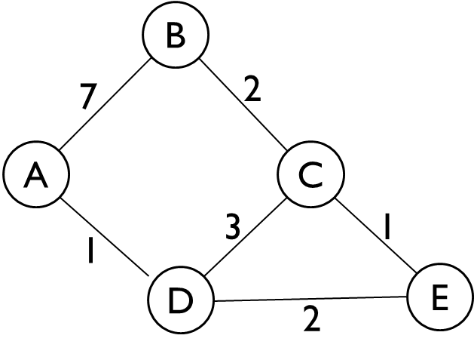
- List the Visit Order of the routers.
- Fill out the Routing Table, keeping track of the Shortest Distance (SD) and Previous Node (PN). When a shorter path is found to a router, cross out the old value and write the new one.
ANS:
a)
b)
Node | SD | PN
A | 0
B
C
D
E

Q3. (10 pts) Distance-Vector Steady State and Failure
Alice (𝐴), Bob (𝐵), Connie (𝐶), and Diego (𝐷) are connected to the local network, which runs the distance-vector algorithm.
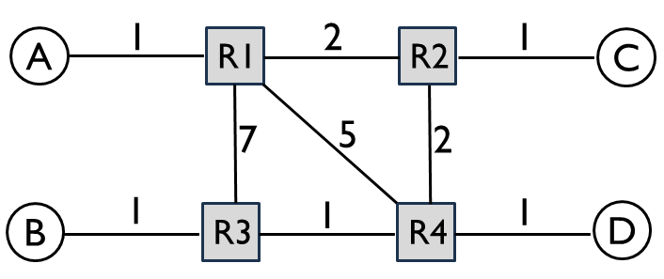
a) Fill in R1’s table at steady state. If a host is directly connected, the next hop is “Direct”.
ANS:
To | Next-hop Router | Cost
A
B
C
D
b) After the network converges, the R1 - R2 link is broken. Fill in R1’s table at the new steady state.
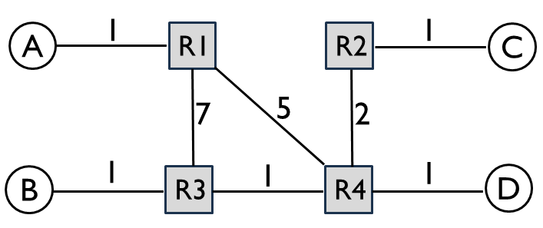
ANS:
To | Next-hop Router | Cost
A
B
C
D
c) After the network converges, the R1 – R4 link is broken. Fill in R1’s table at the new steady state.
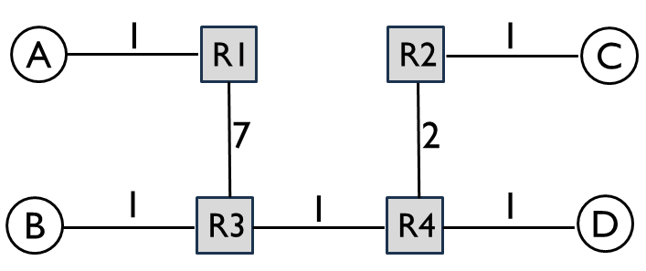
ANS:
To | Next-hop Router | Cost
A
B
C
D

Q4. (15 pts) Link-State
Consider the following network graph with three hosts (A, B, C) and six routers (R1 - R6). For the following questions, assume that the routers run a link-state routing protocol and the routing state has converged. Every link is up unless otherwise noted. When picking between equal-cost paths, the routers pick the route through the neighbor with the lower ID number. For each answer, please provide a concise explanation. Note that all subparts are independent questions (changes made in one subpart do not affect the subsequent ones).
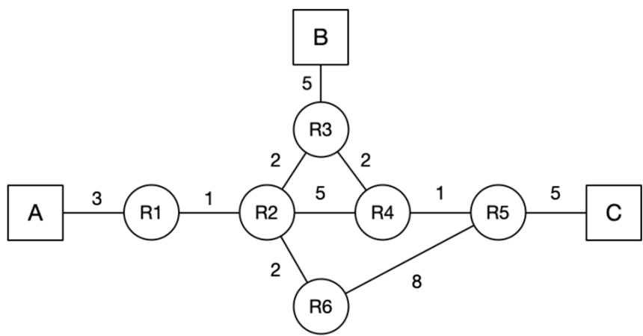
a) (2 pts) Suppose that the link between R2 and R4 goes down. R2 and R4 have recomputed their routes, but have not yet sent updates. What route will a packet from A to C take?
ANS:

b) (3 pts) Suppose that the link between R4 and R5 goes down. R4 and R5 have recomputed their routes, but have not yet sent updates. What route will a packet from A to C take?
ANS:

c) (10 pts) Assume that A sends a packet to C, and at time t=0, it arrives at R1. At t=4.5 seconds, the link between R4 and R5 goes down, and R4 and R5 instantaneously recognize and recompute their routes. Assume that link-state advertisements are processed and propagated instantaneously. A link’s propagation delay is equal to the link costs in the diagram (in seconds). You can ignore all processing and queuing delays. Does the packet reach its destination? If so, write down the route the packet from A to C takes, and fill in the table for the timing of each event, including packet arrivals and LSA arrivals at each router or host.
ANS:
t (s) | Event
0 | Packet arrives at R1

Q5. (10 pts) CIDR Addressing
A university owns prefix 203.0.0.0/16. IP address allocation so far:
- Physics: 203.0.0.0/18
- Chemistry: 203.0.64.0/18
- 203.0.128.0/18 is reserved for CS and Math
- 203.0.192.0/18 is currently unassigned
- (2 pts) What address range is included in Chemistry’s prefix, and how many addresses does it contain?

- (4 pts) Assign 3/4 of the address range within 203.0.128.0/18 to CS, 1/4 of the address range to Math. (Hint: you may need to assign multiple prefixes to the same department.)

- (2 pts) A new Department of Anthropology needs at most 70 addresses. What prefix should you assign from the unused block to minimize waste?

d) (2 pts) After part (c), another Department of Fine Art needs 20 addresses. What is the smallest unused prefix you can assign to minimize waste?
(For each problem, choose the smallest unused prefix to assign next. You can find some useful binary conversions in the table below. You can write out the binary addresses to help you solve problems, but your solution will be graded based on the decimal values only.)
Decimal | Binary
20 | 00010100
40 | 00101000
64 | 01000000
127 | 01111111
128 | 10000000
160 | 10100000
168 | 10101000
172 | 10101100
176 | 10110000
192 | 11000000
200 | 11001000

ANS:

Q6. (10 pts) Longest Prefix Match and Tie-Breaking
A router has 4 ports, with routing table shown below. Use these rules in order: longest prefix match, then lowest cost, then smallest port number. If no prefix matches, use the default route on port 4. Determine which ports the packets with the following destination IP addresses are forwarded to. Give a brief explanation for each.
Port | Destination | Cost
1 | 10.0.0.0/8 | 9
1 | 172.16.0.0/12 | 12
1 | 192.168.128.0/17 | 11
2 | 10.1.0.0/16 | 7
2 | 192.168.0.0/16 | 10
3 | 172.16.32.0/19 | 6
3 | 192.168.192.0/18 | 8
4 | 10.1.2.0/24 | 7
4 | 192.168.128.0/17 | 9
- a) 10.1.2.8
- b) 10.2.1.1
- c) 172.16.40.10
- d) 172.20.1.1
- e) 192.168.200.1
ANS:

Q7. (10 pts) Route Aggregation
Consider a router running longest prefix matching to forward packets. Given the current routing table, use route aggregation to build a new table with the minimum number of entries, such that both tables produce the same forwarding decisions. Write one IP prefix per box.
- (3 pts) Current routing table:
Destination | Port
150.10.0.0/24 | 1
150.10.1.0/24 | 1
150.10.2.0/24 | 1
150.10.3.0/24 | 1
150.10.4.0/24 | 1
150.10.5.0/24 | 1
ANS: Fill in merged routing table (you may need more or less than 3 rows):
Destination | Port

- (4 pts) Current routing table:
Destination | Port
150.10.0.0/24 | 1
150.10.1.0/24 | 1
150.10.2.0/24 | 2
150.10.3.0/24 | 3
150.10.4.0/24 | 3
150.10.5.0/24 | 3
ANS: Fill in merged routing table (you may need more or less than 3 rows):
Destination | Port

- (3 pts) Current routing table:
Destination | Port
150.10.0.0/24 | 1
150.10.1.0/24 | 1
150.10.2.0/24 | 2
150.10.3.0/24 | 1
150.10.4.0/24 | 1
150.10.5.0/24 | 1
ANS: Fill in merged routing table (you may need more or less than 3 rows):
Destination | Port

Q8. (5 pts) Binary Tries
a) (2 pts) Build a binary trie for prefixes 25.0.0.0/15, 25.1.0.0/16, and 25.1.128.0/17. What is the trie height? Describe the structure.
b) (3 pts) Build a binary trie for prefixes 40.0.0.0/8 and 43.128.0.0/8. What is the trie height? At what earliest level does branching happen?
ANS:

Q9. (10 pts) Inter-Domain Routing under Gao-Rexford
Consider the AS graph below, where each AS follows the Gao-Rexford import and export policies. For each source/destination pair, select whether it is possible for packets to be sent from the source AS to the destination AS. Does the AS graph have full reachability from every AS to every other AS? If not, fill out the following table of reachability. (Hint: Every intermediate AS on a legal path must have at least one customer neighbor along that path.)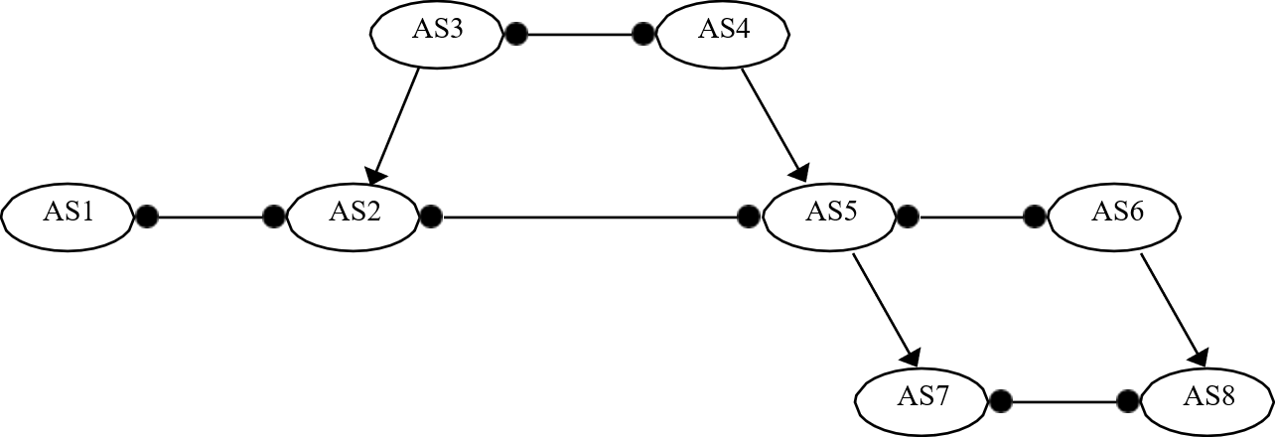
ANS:
Source AS | Reachable Destinations
AS1
AS2
AS3
AS4
AS5
AS6
AS7
AS8

